

**UE21CS351A: Database Management System**

**RENTAL SERVICE MANAGEMENT SYSTEM USER REQUIREMENT SPECIFICATION**

**NAME: PRASHIL HIMANSHU JATAKIYA**

**SRN: PES2UG21C211**

**SECTION: D**

**1. Introduction**

**1.1 Scope**

The future scope of this Rental Database Management System (DBMS) project includes the potential for ongoing enhancements and expansions. Future developments could involve the integration of advanced features such as predictive analytics for costume demand, the incorporation of augmented reality (AR) or virtual reality (VR) for virtual costume try-ons, and the implementation of mobile applications for convenient on-the-go costume reservations. Additionally, the system could be scaled to accommodate multiple rental locations or even be extended to serve other related businesses like prop rentals or event planning services. Continual updates and improvements would ensure that the DBMS remains competitive and adaptable to evolving customer needs and technological advancements in the rental industry.

**1.2 Purpose**

The purpose of a Rental Database Management System (DBMS) project for college is to develop a comprehensive software solution that serves several important purposes:

a. Efficient Rental (costume, props, footwear, jewellery) Management:

The primary purpose is to streamline and automate the management of arental service. It allows the rental business to keep track of their costume, props, footwear, jewellery inventory, ensuring that items are organized, cataloged, and readily available for customers to rent.

**2. Project Overview**

**2.1Project Description**

The Rental Database Management System is a comprehensive software solution designed to facilitate the efficient management of a rental service. The system allows admin to perform essential operations including item rental, return, addition, and deletion, ensuring seamless day-to-day operations for administrators .

**2.2Major Project Functionalities**

**a. Rental:**

* Customers can easily browse through an extensive catalog of items, view details, and place rental orders.
* The system calculates rental fees based on predefined pricing rules and duration.

**b. Return:**

* Admins can initiate returns through the system.
* Admins can verify returned costumes, update their availability status.

**c. Add Item:**

* Administrators have the capability to add new costumes to the inventory.
* When adding a item(costume, footwear, props, jewellery), they can provide essential details such as costume id, description, size, rental price, and availability status.

**d. Delete Item:**

* Admins can also remove items from the inventory when they are no longer available for rental.
* Deletion ensures that items no longer appear in the customer catalog.

**User Roles:**

* Admin: Manages the item inventory, customer accounts, and rental transactions. Admins have full access to add, delete, and edit item records.
* Customer: Browses the item catalog.

**3.System Features and Function Requirements**

**System Feature 1: Rental**

Functional Requirements:

a. Catalog:

* Customers can browse a categorized catalog of available items.
* Each item listing includes details such as id, category, rental price, and availability status.

b. Rental:

* Admin can check the availability of an item and if it is available, the item will be rented to the respective customer

c. Inventory Update:

* Upon successful rental, the system automatically updates the item's availability status and logs the transaction.

**System Feature 2: Return**

Functional Requirements:

a. Return Initiation:

* Admin can initiate a return by assessing the item condition and update the database
* Inventory Update:
* Admins can verify returned item, update their availability status.

**System Feature 3: Add Item**

Functional Requirements:

a. Addition:

* Admins can add new items to the inventory.
* When adding a item, they must provide details such as item id, category, rental price, and initial availability status.

**System Feature 4: Delete item**

Functional Requirements:

a. Deletion:

* Admins can remove items from the inventory when they are no longer available for rental.
* Deleted items should no longer appear in the customer catalog.

**RELATIONAL SCHEMA:**

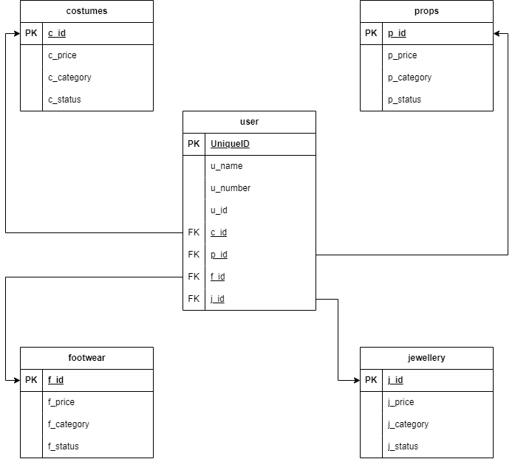

**ENTITY-RELATIONSHIP(E-R) DIAGRAM:**

